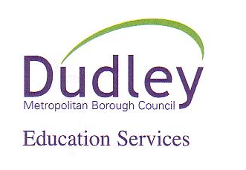
Old Park School
Thorns Road
Brierley Hill
West Midlands
DY5 2JY

Tel: 01384 818905
Fax: 01384 818906

Headteacher: Miss J Colbourne
E-mail: office1@old-park.dudley.sch.uk

Old Park Health Team – Update & Contacts

Dear Parent/Carers,

We would like to take this opportunity to remind you of the following details and contacts for the health team at Old Park. Denise Garland has now left the team, please see below the details of the new School Nurse who will be joining Old Park in due course.

Sarah Simmons (Special School Nurse) – 01384 818927
Mobile – 07585545024
Email – sarah.simmons@nhs.net

Ruth Stringer (Special School Nurse)
Mobile & email to be advised

Health Email: bchft.opshealth@nhs.net

Health Care Support Workers:
Wendy, Kelly & Brigitte
They will continue to provide care for our children requiring a package of care in school.

If you have any questions, please don’t hesitate to contact the school on: 01384 818905

Kind Regards

Old Park School & the Health Team.

